 Hale School

Semester 1, 2012

Question/Answer Booklet

MATHEMATICS
Circle your teacher’s initials

STL MAV

SPECIALIST 3CD

Section One

(Calculator Free)

Your name

Time allowed for this section

Reading time before commencing work: 5 minutes
Working time for paper: 50 minutes

Material required/recommended for this section

To be provided by the supervisor
Question/answer booklet for Section One.
Formula sheet.

To be provided by the candidate
Standard items: pens, pencils, pencil sharpener, highlighter, eraser, ruler.

Important note to candidates

No other items may be taken into the examination room. It is your responsibility to ensure that you do not have any unauthorised notes or other items of a non-personal nature in the examination room. If you have any unauthorised material with you, hand it to the supervisor before reading any further.

Structure of this examination

 | Number of questions | Working time (minutes) | Marks available
This Section (Section 1)  Calculator Free | 8 | 50 | 50
Section Two  Calculator Assumed | 12 | 100 | 100
Total marks |  |  | 150

Instructions to candidates

- The rules for the conduct of WACE external examinations are detailed in the booklet WACE Examinations Handbook. Sitting this examination implies that you agree to abide by these rules.

- Answer the questions in the spaces provided.

- Spare answer pages are provided at the end of this booklet. If you need to use them, indicate in the original answer space where the answer is continued i.e. give the page number.

- Show all working clearly. Your working should be in sufficient detail to allow your answers to be checked readily and for marks to be awarded for reasoning. Incorrect answers given without supporting reasoning cannot be allocated any marks. Any question, or part question, worth more than 2 marks requires valid working or justification to receive full marks. If you repeat an answer to any question, ensure that you cancel the answer you do not wish to have marked.

It is recommended that you do not use pencil except in diagrams.

1. [6 marks]

(a) Given the following matrix equation:

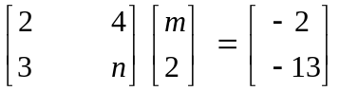,

determine the value of m and n.
[3]

(b) If P and Q are square matrices and PQ = P + Q, then determine P in terms of Q.

[3]

2. [4 marks]

Simplify 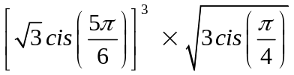

3. [7 marks]

For each of the following functions, find .

(a) 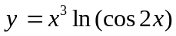 [in terms of x]

[3]

(b) 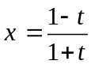 and 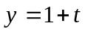 [in terms of y]

[4]

4. [6 marks]

(a) The locus of the complex number z satisfies the equation 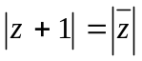.
Determine the Cartesian equation of this locus.

[4]

(b) Given that 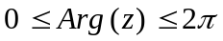, sketch, on the Argand plane below, the region defined by
{z | Arg (z²)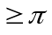}.

[2]

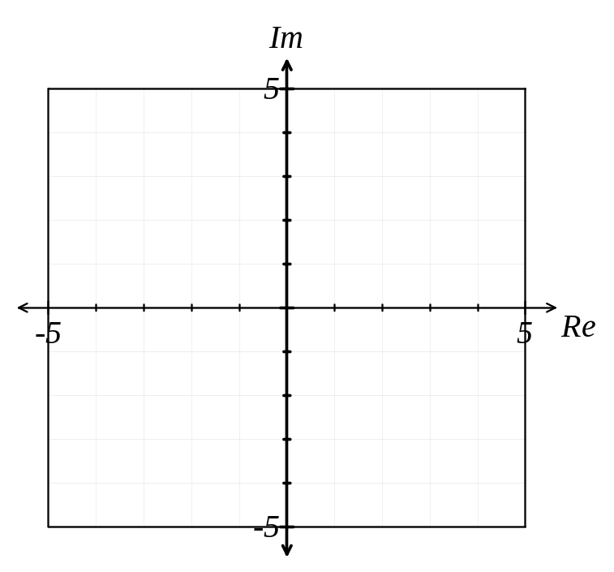

5. [7 marks]

The function f (x) is defined by f (x) = 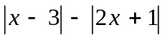.

(a) Rewrite f (x) in piecewise defined form.

[3]

(b) On the grid below, sketch the graph of y = f (x).
[2]
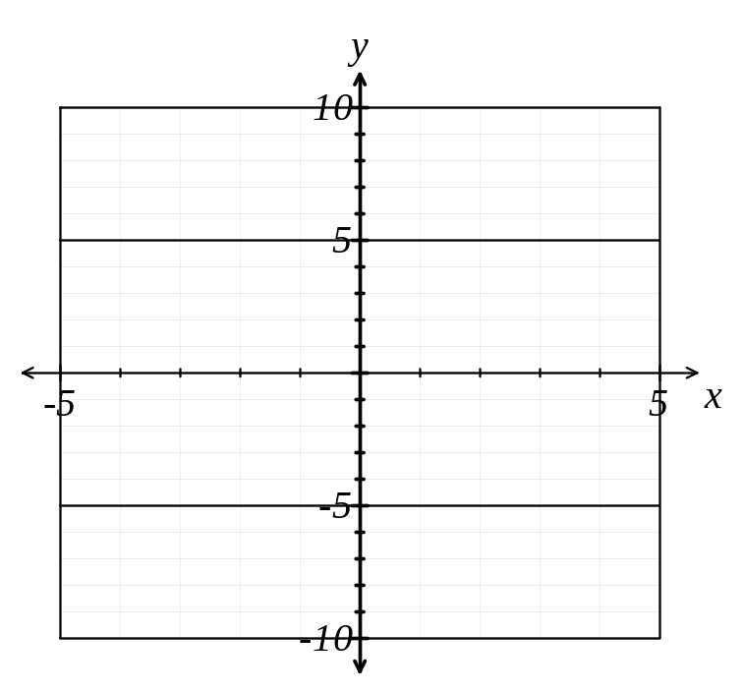

(c) For what values of x is 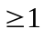 ?
[2]

6. [8 marks]

Using the method of proof by exhaustion, prove that 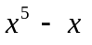 is divisible by 5 for integers 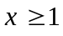.

7. [4 marks]

Determine 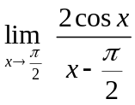 showing your full reasoning.

8. [8 marks]

Given that a = 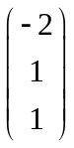 , b = 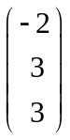 and c = 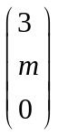,

(a) determine the value of m such that b is perpendicular to c.

[2]

(b) show that the cosine of the angle between a and c, in terms of m, is 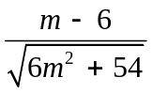.

[3]

(c) determine vector d such that the magnitude of d is 3 times the magnitude of b and in the same direction as a.

[3]

SPARE PAGE FOR WORKING

